**Explainable recommendation with fusion of aspect information**

**1 Introduction**

Recently, some methods utilizing aspect information extracted from review text have been proposed [10, 22, 39, 46], where two types of aspects are defined. One is defined as a noun word or phrase representing an item feature [10, 46]. The other type of aspect is defined as a set of words that characterize a topic of item in the reviews [22, 39].

challenges：

**Quantitative Evaluation of Aspect**

**Fusing Aspect Information into Recommendation**

To address these challenges, in this paper, we propose an Aspect-based Matrix Factorization model, called AMF.

Our main contributions can be summarized as follows:

1. We propose an Aspect-based Matrix Factorization model (AMF) for explainable recommendation, which can improve the accuracy of rating prediction by fusing auxiliary information extracted from aspects into the factorization of item rating matrix.

2. We propose two metrics, User Aspect Preference (UAP) and Item Aspect Quality (IAQ), by which we can quantify the user preference to an aspect and assess the review sentiment of item on an aspect, so as to make the recommendations explainable and convincing.

3. The extensive experiments conducted on real datasets verify the recommendation performance and explanatory ability of our approach.

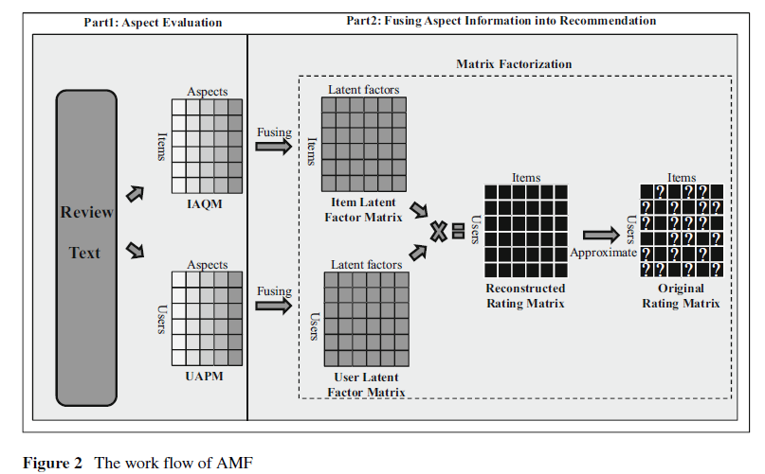

**2 Aspect evaluation**

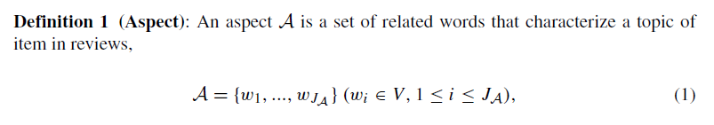

According to the concept of aspect, we extract aspects (denoted by A1, ..., AL) from review dataset and map the words of each review onto corresponding aspects.

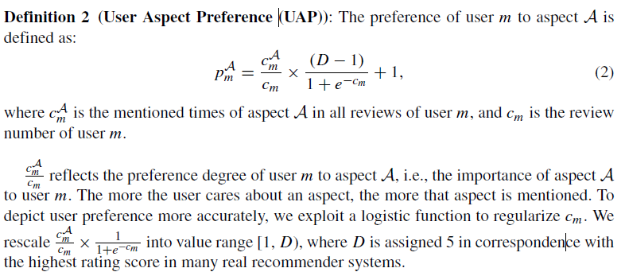

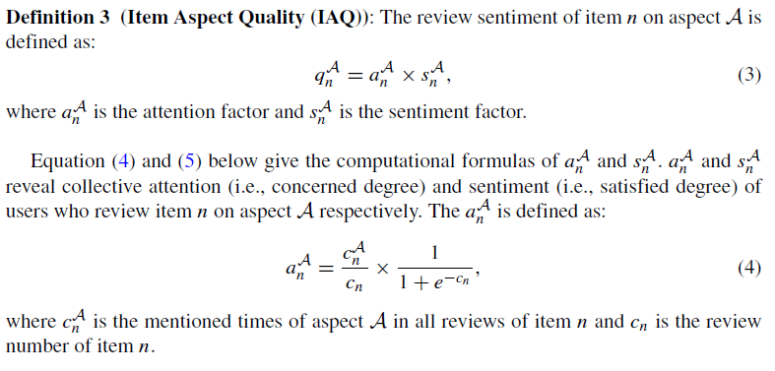

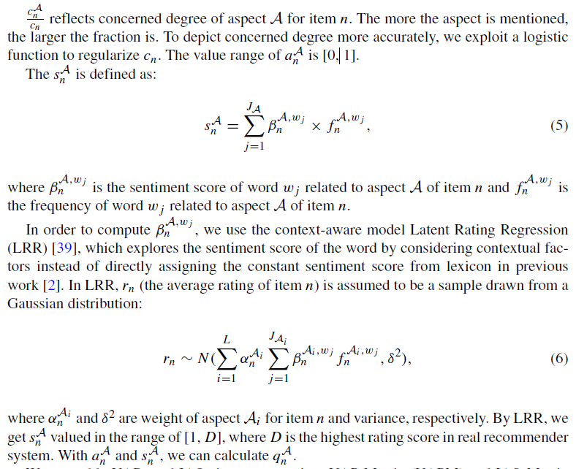

We assemble UAPs and IAQs into two matrices UAP Matrix (UAPM) and IAQ Matrix (IAQM), which are formally defined as follows:

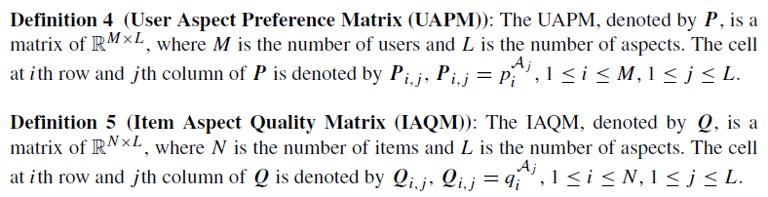

**3 Aspect-based matrix factorization**

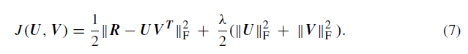

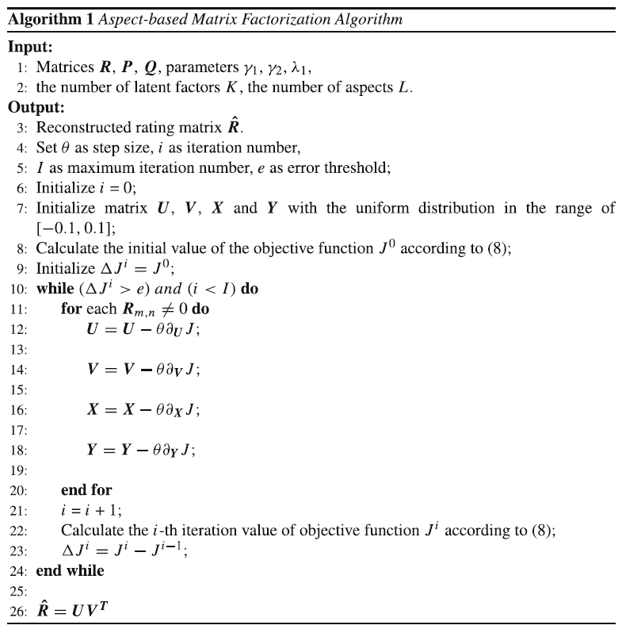

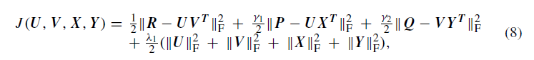

**4 Experiment**

**4.1 Settings**

*4.1.1 Dataset*

*4.1.2 Baselines*

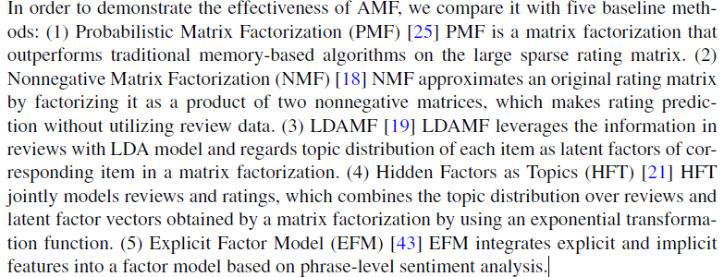

*4.1.3 Model evaluation*

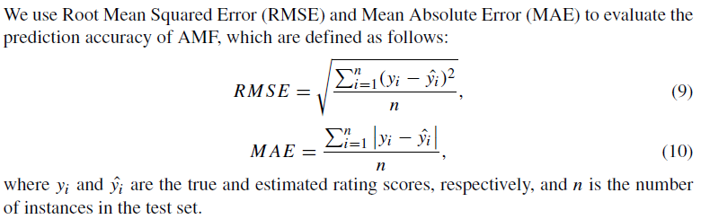

**4.2 Sensitiveness of parameter**

**4.3 Prediction accuracy**

**4.4 Case studies**

**5 Related work**

**Collaborative filtering**

**Topic-based explainable recommendation**

**Sentiment-based explainable recommendation**

**6 Conclusions**

In this paper, we propose an Aspect-based Matrix Factorization model (AMF) for explainable

recommendation. AMF makes recommendation by fusing auxiliary aspect information

extracted from reviews into matrix factorization. To quantitatively evaluate aspects, we propose

two metrics: User Aspect Preference (UAP) and Item Aspect Quality (IAQ). UAP

reveals user preference to a specific aspect and IAQ assesses the review sentiment of item

on an aspect, by which we can make the recommendations explainable and convincing. To

improve the accuracy of rating prediction, we assemble UAPs and IAQs into two matrices

UAP Matrix (UAPM) and IAQ Matrix (IAQM), respectively, which are used as constraints

fused into collaborative decomposition of the item rating matrix. The results of the extensive

experiments conducted on real datasets verify the recommendation performance and

explanatory ability of AMF.